Now suppose just modify one file “SampleDoc.txt” by adding/removing some lines in that file.

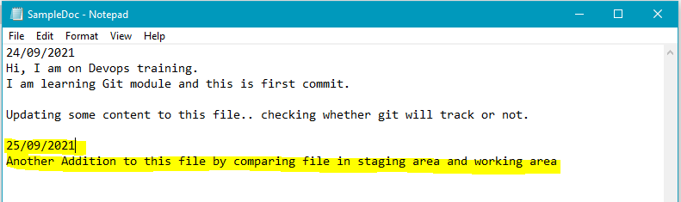

Now in order to compare the files modified which are in staging area and working area, use the below command “git diff”.

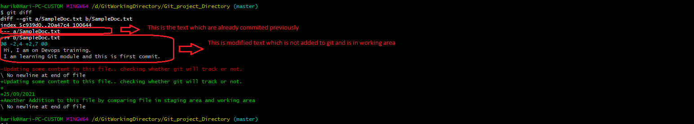

Now you can modify another file “SecDocument.txt” and see the git diff whether it report differences for both files or not.

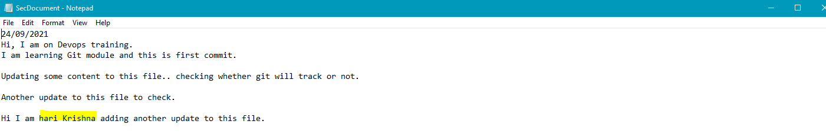

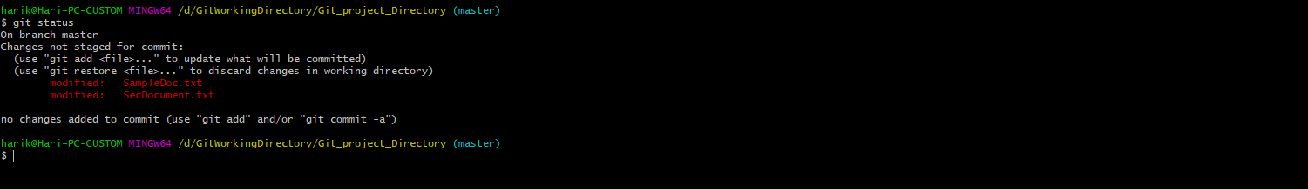

Note: No matter whether 1 file or multiple files modified you need to issue the command “git diff”.

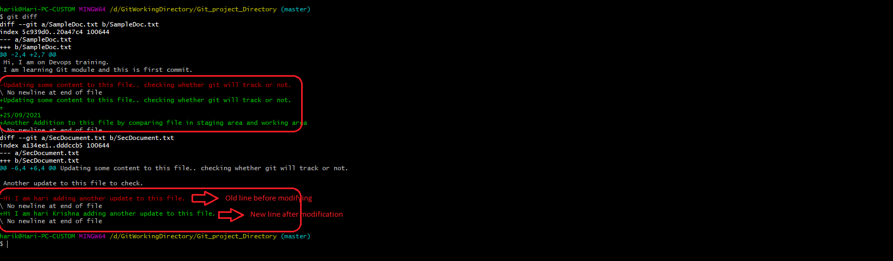

Now we can add new file “Testfile.txt” and see how it is tracked.

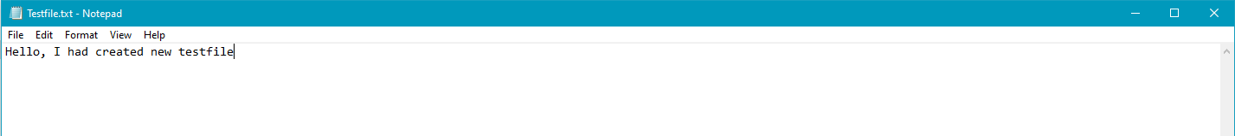

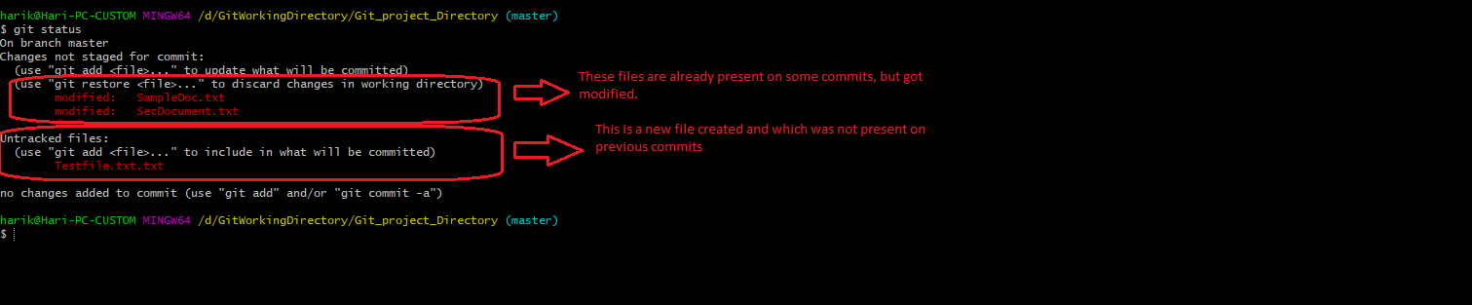

Now we will issue the git diff command and see whether the new files are getting tracked or not.

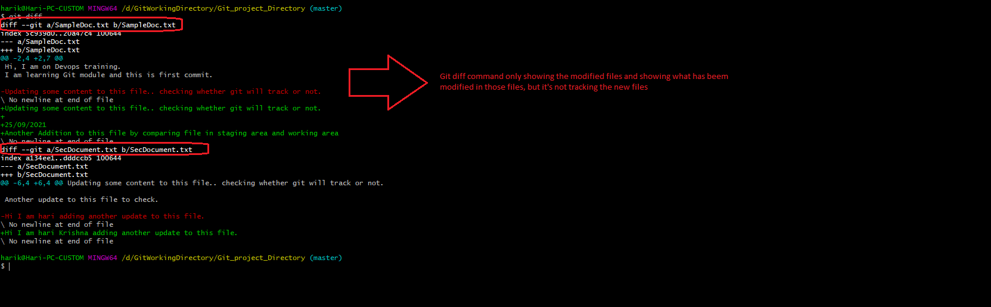

In the above screenshot git diff is not tracking the updates for the new created files. Now add only the file “Testfile.txt” to staging area and see the difference.

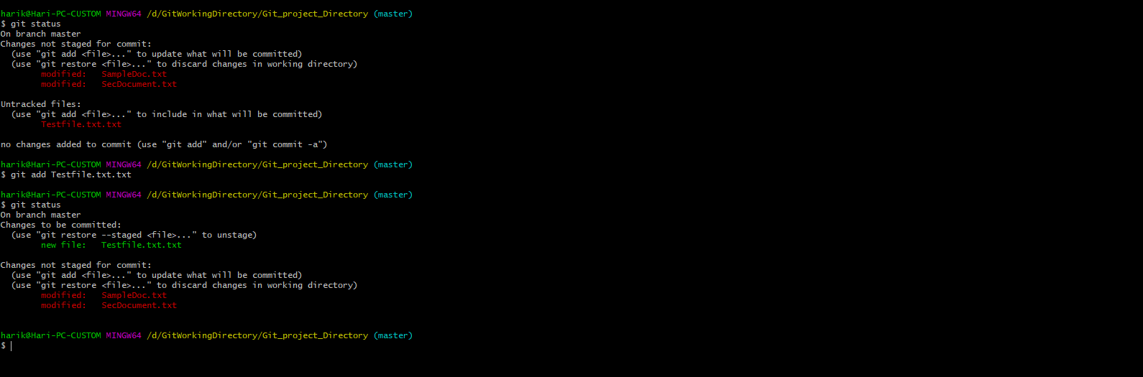

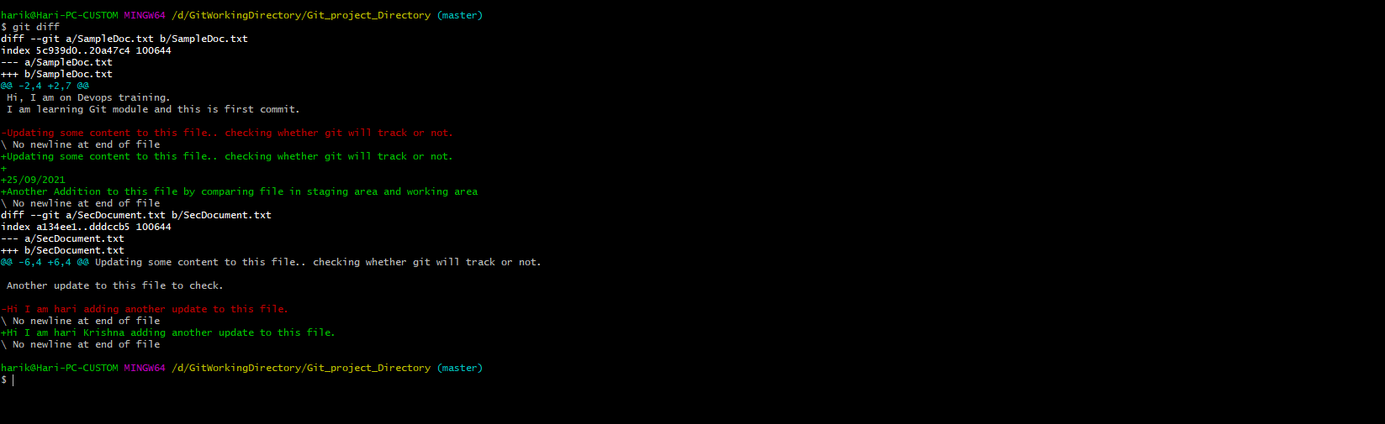

You can see even those we placed the “Testfile.txt”, git diff is not tracking the differences for that file.

Now add all the files to the staging area and issue the git diff command. It won’t track any differeneces.

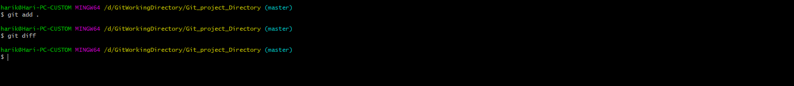

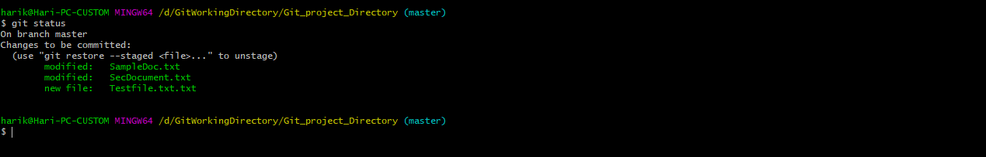

Git diff will compare the differences between the files which are in staging area and in working area which are modified and if no file is there in staging area it will compare the file with working area.

